Completing the Service Agreement Compliance Certificate in the Service Agreement Module
Contents
Introduction 2
What is Service Agreement Compliance Certification? 2
Using this guide 3
Registration for My Agency 4
Completing your SACC 4
Navigate to the Service Agreement Module 4
Adding FAR/ACFE BGS documentation to the SACC record 5
Open and complete the SACC form 7
View a submitted SACC 8
Update annual general meeting date 9
View SACC reports 10
Contact Department Adviser 10

Introduction

What is Service Agreement Compliance Certification?
Agencies that have a Service Agreement with the Department of Health and Human Services (DHHS), the Department of Education and Training (DET) and/or Adult, Community and Further Education Board (ACFE) must complete a Service Agreement Compliance Certification (SACC) to annually attest compliance with their contractual obligations.
These obligations are outlined in the Service Agreement and the Service Agreement Requirements, including:
- Financial management
- Funding has been used as outlined in the agency’s Service Agreement.
- The agency is financially viable and able to continue to provide services.
- Financial reports and other audit reports have been prepared and the agency maintains an asset register.
- For agencies that only receive ACFE funding, a Business and Governance Status (BGS) assessment is required. An annual report for ACFE funding is not required.

- Risk management
- Risks are managed in accordance with the Australian/New Zealand Risk management standard.
- Risks are reviewed annually.
- The board or other oversight committee have confirmed that the agency’s risk management practices are satisfactory.

- Safety screening
- Safety screening checks are in accordance with the Department of Health and Human Services Safety screening policy.
- Police record check (or International police record check if lived overseas for 12 months or longer), referee check and Working with Children checks have been completed.

- Privacy
The agency’s practices and systems are compliant with the Privacy and Data Protection Act 2014 (Vic), the Health Records Act 2001 and the Privacy Act 1988 (Cth).

- Occupational Health and Safety
The agency has policies, procedures and systems in place that comply with the Occupational Health and Safety Act 2004 and to ensure employees are being trained on the management of all safety hazards and risks relevant to services provided to clients.

- ACFE Business and Governance Status (BGS)
The agency has submitted an ACFE BGS assessment or is eligible for an exemption under current ACFE guidelines (note: reference to ACFE BGS or a Vocational Educational and Training (VET) funding contract under the Skills First Program in this document is applicable when the agency is funded by ACFE). For agencies funded only by ACFE, a BGS assessment is required.

The SACC will need to be completed and submitted in the Service Agreement Module within My Agency. By submitting a SACC form, agencies are making a commitment to the department that they have appropriate systems and processes in place to comply with the relevant Service Agreement obligations.
The organisation officer submitting the SACC form must be a director, chairperson, chief executive officer, president, principal, treasurer or similarly authorised roles.
Before submitting the SACC form, all questions in the displayed sections must be completed. Depending on your reporting requirements, the system will only display the sections that your agency is required to complete. If you do not agree with what is displayed, contact your department adviser listed for your agency in SAM.
The SACC form comprises the following sections:
- financial management
- risk management
- safety screening
- privacy
- occupational health and safety
- ACFE BGS (only applicable to ACFE funded agencies)

The organisation user will generally have an option to choose from Yes/No/In Part as their response. For some question user will also be able to choose the option “Not applicable”. If you answer 'No' or 'In Part' to any of the questions, you will be required to provide some brief details of the actions your agency is taking to improve practices in response to the questions. You will also be contacted by your department adviser to discuss your answer/comments.
The SACC can be saved at any time, allowing for different areas of your agency to individually complete different sections. The SACC is due 90 days after the end of your agency's reporting period. However, if your agency's annual general meeting (AGM) is after the due date you can now insert your agency's AGM date in SAM and the SACC due date will automatically update to seven days after the AGM.
If an agency is unable to lodge its SACC online, they can complete a hard copy. However, this should only occur in exceptional circumstances as department staff will then have to complete the form online in SAM (Service Agreement Module).

Using this guide
This document includes information on how to complete the SACC in My Agency. The document provides sequential steps and screen shots to outline the process of submitting SACC.
It provides guidance to assist with:
- navigating to the compliance tab to establish what action you need to take
- attaching financial accountability requirements (FAR) and/or ACFE BGS documentation to the SACC record
  - completing, saving and submitting your agency's SACC
  - adding or amending your agency's annual general meeting date.

A red box outline in each screenshot of this guide will identify the area you need to select, action or note. In the example screenshot below, the agency name is being identified.
Screen shot 1: Example screenshot
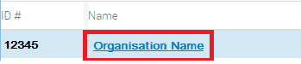
For additional information regarding the purpose of SACC, the roles of funded agencies and departmental staff and the scope of questions, please reference the Service Agreement Compliance Certification (SACC) guidelines. The guidelines are available on Funded Agency Channel <https://fac.dhhs.vic.gov.au/service-agreement> under Service Agreement page.
The video 'How to complete the SACC ' is an additional resource to support funded agencies to complete the SACC. It is available in My Agency under Learning resources.

Registration for My Agency
My Agency is the secure area of the Funded Agency Channel (FAC) website where registered users from funded agencies can access funding and payment information about their Service Agreement.
If you require access to My Agency and are not a registered user, please refer to Funded Agency Channel <https://fac.dhhs.vic.gov.au/my-agency-non-dhhs-staff> under My Agency for non-DHHS staff page.

Completing your SACC

Navigate to the Service Agreement Module
- Log into My Agency (via eBusiness). From the My Agency page, select: Service Agreement Module [External Link]
Screen shot 2: Navigating to the Service Agreement Module
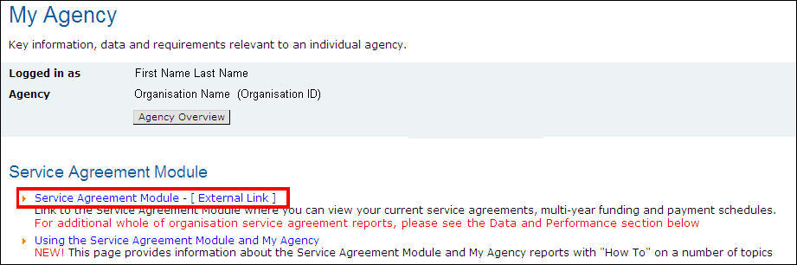

- A new window will open, and SAM will display. The Organisations tab at the top of the screen is selected by default. Select the hyperlink (blue text) with the name of your agency.
Screen Shot 3: Service Agreement Module main page
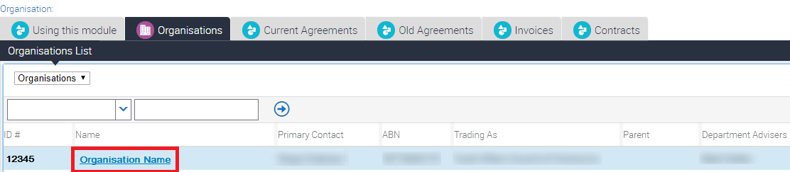

- The Organisations screen will open with a series of lower level tabs below the Organisation Details section. The Contacts tab will load by default. Select the Compliance tab.
Screen shot 4: Compliance tab in Service Agreement Module
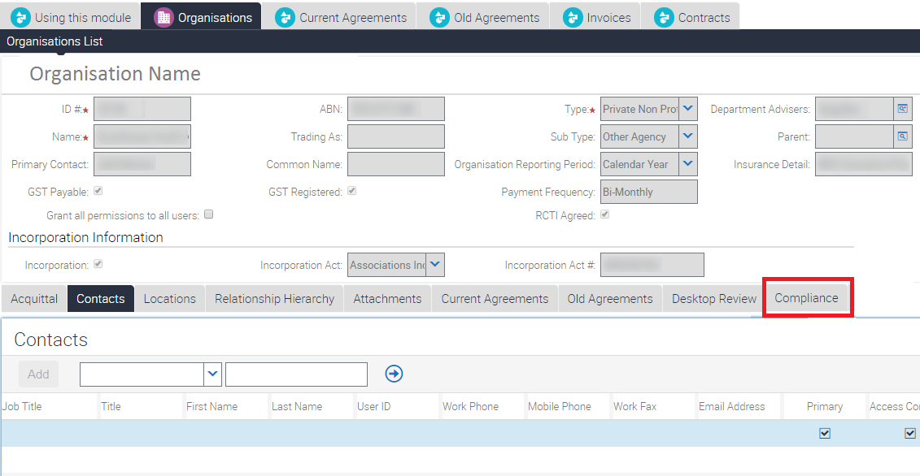

- Select the SACC record to be completed. Ensure that the record you are working on has a status of Open.
Screenshot 5: Select SACC record
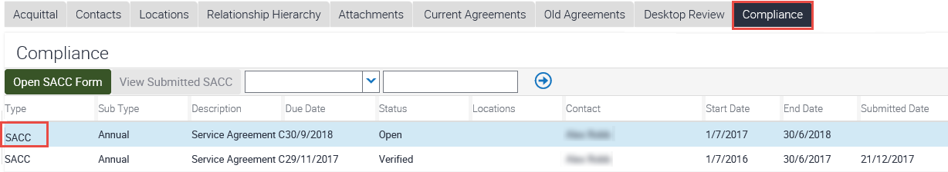

Depending on your agency's reporting requirements, you may or may not need to attach financial accountability requirements (FAR) documentation and/or ACFE BGS. If you are unsure, please refer to the Service Agreement Compliance Certification (SACC) guidlines <https://fac.dhhs.vic.gov.au/service-agreement>.
If you are not required to provide financial documentation and/or ACFE BGS, as part of your FAR or ACFE BGS requirement, go to step 8.
If you are required to provide financial documentation and/or ACFE BGS, go to step 5.

Adding FAR/ACFE BGS documentation to the SACC record
If you are required to provide financial documentation, as part of your FAR, you can:
    - add a copy of your annual report containing financial statements or
    - add a URL to a publicly accessible website, if your annual report is available online.
If your agency doesn't produce an annual report, you can complete a financial indicator statement (FIS) or a cash indicators statement (CIS). FIS and CIS templates can be downloaded from the Funded Agency Channel. If you are required to provide ACFE BGS document, as part of ACFE guidelines, you can add a copy of your BGS.

- On the Compliance tab, select the SACC record to be completed via selecting the word SACC on the far left of the record. The record will be highlighted. Scroll to the bottom of the screen and locate the Attachments section. Select New File.
Screen shot 6: Locate attachments section
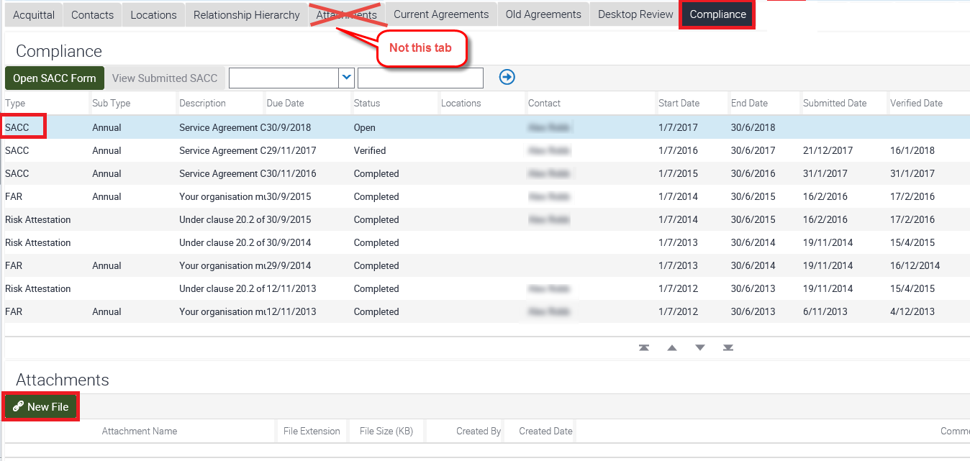

- The Choose File to Upload pop up box will display. Highlight the document you wish to attach (you can only upload one document at the time) and select Open.
Screen shot 7: Upload attachment
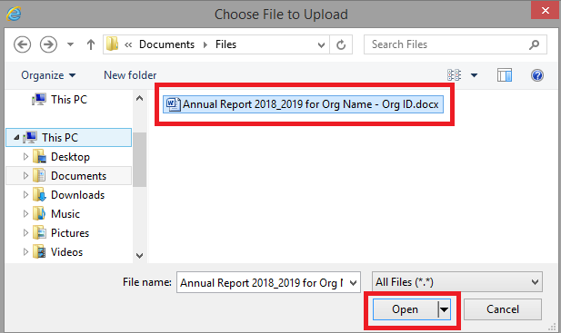

- This will take you back to the Compliance Attachments section and the document you added will display in the Attachment Name field. If required, you may also add comments (in the Comments field).
Screen shot 8: Document uploaded in the attachment section
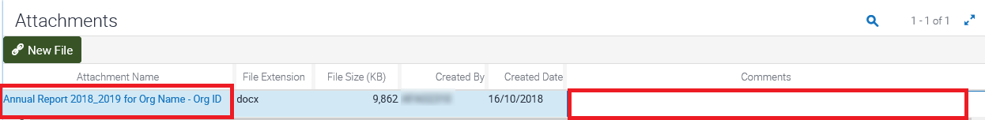

Open and complete the SACC form
- Ensure the SACC record to be completed is highlighted, by selecting the word SACC on the far left of the record. Select the Open SACC form button.
Note: The Open SACC form will only become active after the reporting period end date. Until then, it will not be visible.
Screen shot 9: Open SACC form button
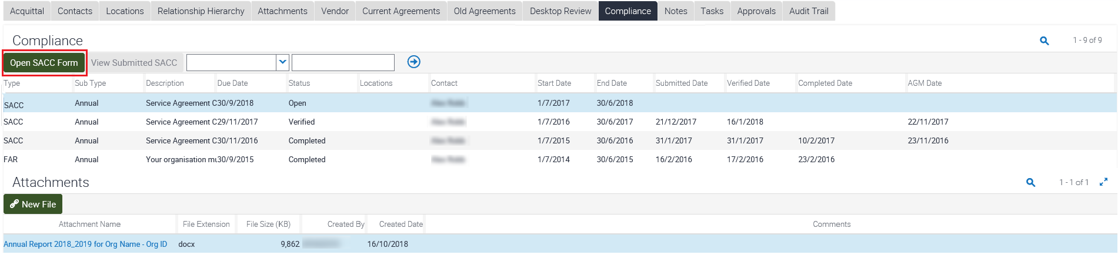

- The SACC form will display. There are six sections, with only the sections your agency is required to complete being visible. Answer questions by selecting the most appropriate radio button.
You can save at any time by selecting “Save” button at the bottom of the form and return to complete the SACC at a later stage, allowing for different areas of your agency to individually complete different sections. Once all the questions have been responded to, select the “Submit” button at the bottom of the form.
Screen shot 10: An open SACC form displaying the Financial Management section
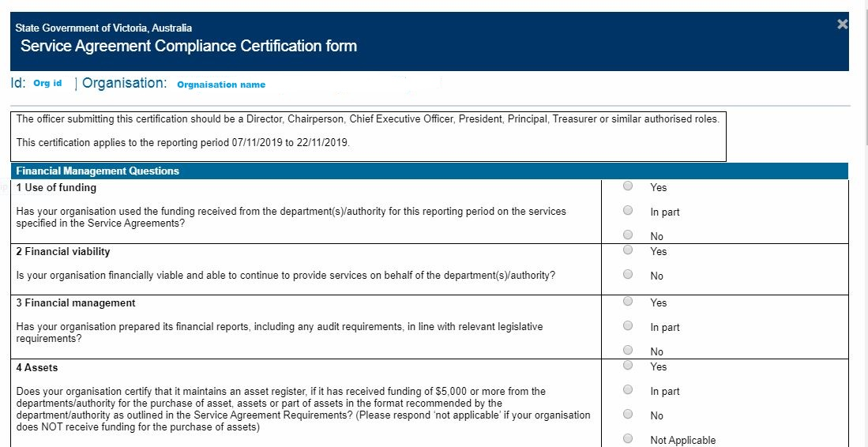

After submitting your SACC, the following message will display in the window: “Thank you for completing your Service Agreement Compliance Certification form”.
Both you and your agency's primary contact will also receive a system generated email confirming that the SACC has been submitted.
Select the Close button to return to the Compliance tab.

View a submitted SACC
You can view the information provided in any SACC with a status of Submitted, Verified or Completed. Choose the SACC record you wish to view, by selecting the word SACC on the far left of the record. The row will then be highlighted. Select the View Submitted SACC button. The SACC form in its entirety will display in a pop up box. It will show the original form with the answers selected and any comments displayed.

Screenshot 11: View submitted SACC form
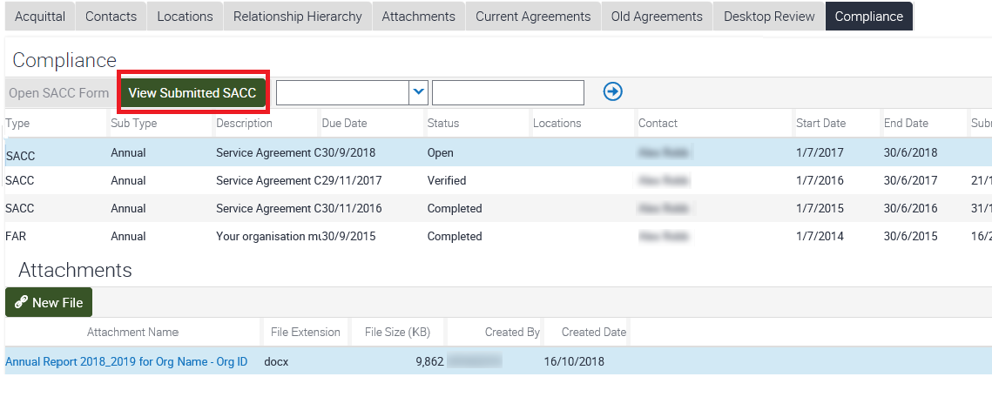

Update annual general meeting date
If your agency's AGM occurs after the SACC due date, you can update the AGM date and the due date will automatically change to seven days after the AGM.
Ensure the SACC record to be updated with the AGM date is selected by selecting the word SACC on the far left of the record. The record will be highlighted.
You can either enter the date (dd/mm/yyyy) in the AGM Date field or select the calendar icon to the right of the field.
If you selected the calendar icon (to the right of the AGM Date field) a calendar pop up box will display.
Select the Month, Year, Day and the Save button in the Calendar pop up box. This will close the Calendar pop up box and insert the date you have selected in the AGM Date field.
Once the date is in the AGM Date field (via direct entry - dd/mm/yyyy - or via the calendar icon), the Due Date will automatically change to seven days after the AGM date.

Screen shot 12: Change AGM date
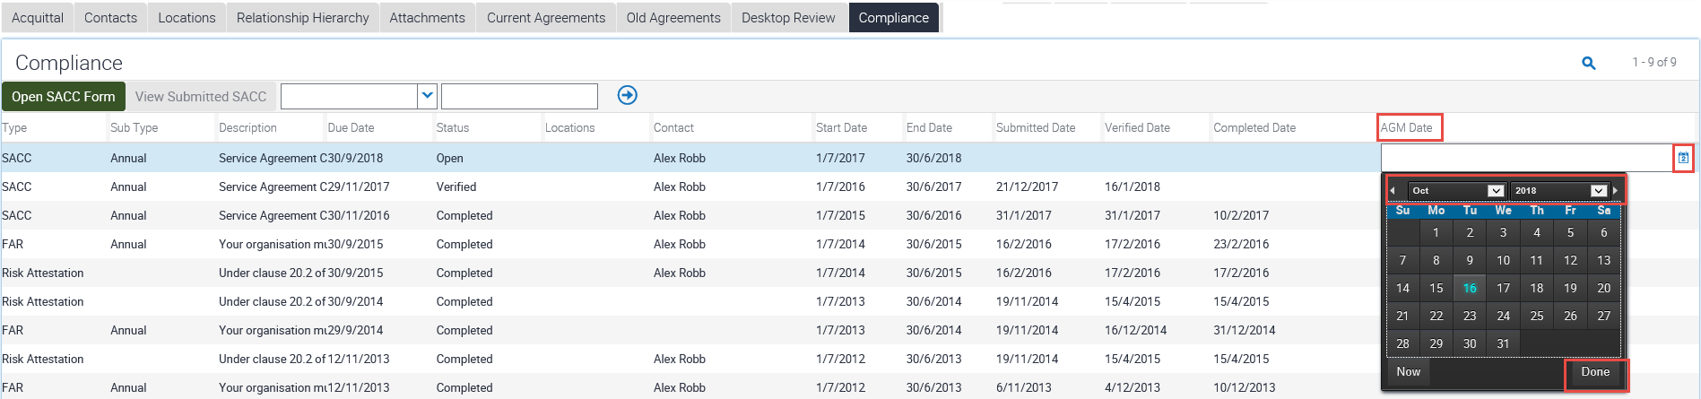

View SACC reports
A SACC report is available in My Agency under the compliance reports section. The report displays the questions, answers and any comments provided to the SACC questions.

Contact Department Adviser
You can contact the department adviser listed for your agency in SAM. Select the icon to the right of the department adviser for contact details.
Screen shot 13: Department adviser contact details
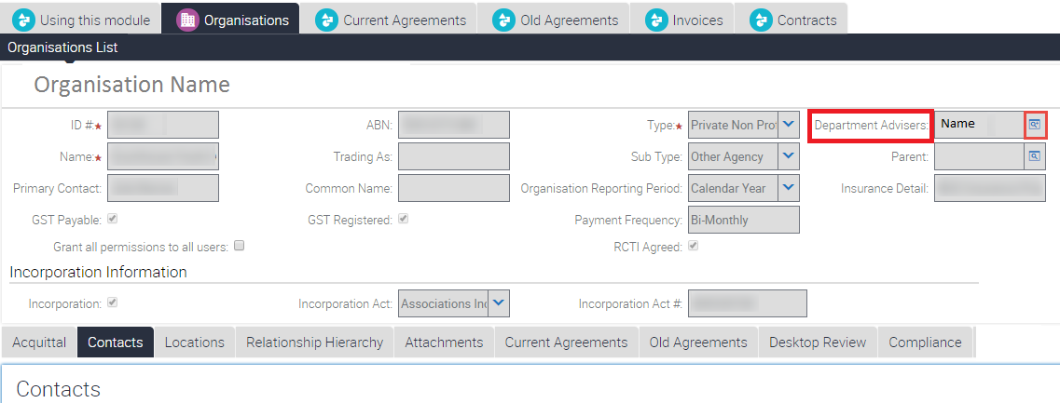

To receive this publication in an accessible format, email: the Funded Agency Channel <fac@dhhs.vic.gov.au>
Authorised and published by the Victorian Government, 1 Treasury Place, Melbourne.
© State of Victoria, Department of Health and Human Services, June 2020.
Available on the Funded Agency Channel <https://fac.dhhs.vic.gov.au/service-agreement>

